

Online Host, Visualization, and Deployment

**Submitted by**

**Vamsi Draksharam: Class id -9**

**Goutham Gandreddi: Class Id -11**

**Premchand Lingamgunta: Class id - 15**

**Project Goal and objectives:**

**Motivation:**

Abundant models and iterative tests on the models, raised the need for a system to capture and host a model, visualize the results and sharing the trained models online becomes a crucial step of the overall deep learning lifecycle.

**Objective:**

As mentioned above, ‘online host, visualization and deployment’ gives the user a platform where user can upload or download the models or pretty much anything. User can view any model as a separate module and can comment and rate the model.

We are following the MEAN stack approach using Angular as front-end application framework, to create the views for user interaction, Node js and Express to handle the business logic and establish the connectivity to database, for user validations and retrieving the details regarding the models. The Discussion form for each issue is going to have a thread of comments and other features which are planning to be implemented.

**First increment Report:**

**Detail Design of Features:**

The increment is mainly divided into three sections,

* Sign-in: Design and develop the input fields for the login component based on user input and validating the details if he is a existing user or not.
* Sign-up: designing and developing the sign-up page and validate the user inputs against the standards set by the application and store the user details if there are no errors.
* Home Page: The Home page has the menu for navigating through features like, displaying the menu for user information, user models, search bar for searching the models.

Create the required tables for the user authentication and registration details for validation purposes and test the data.

**Wireframes and Mockups:**

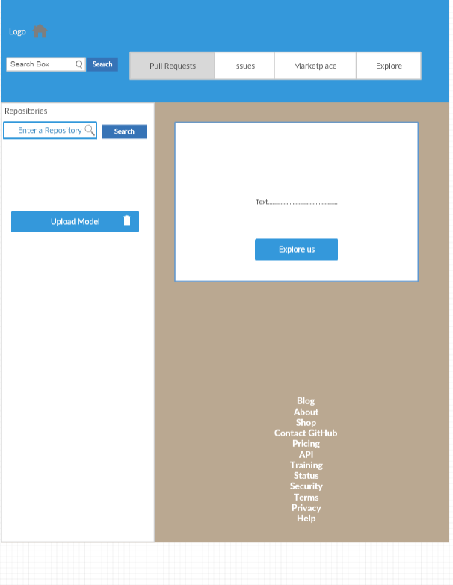

**Login Page:**

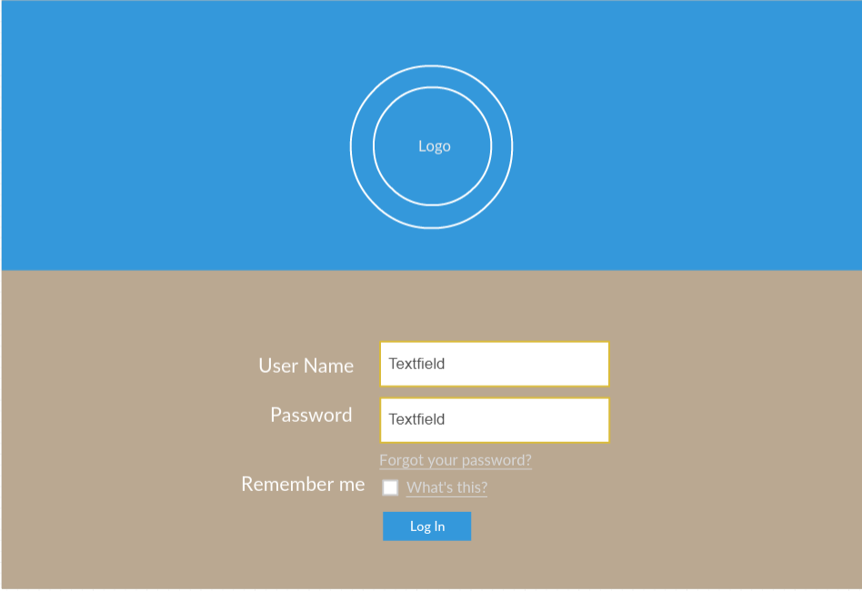

**Registeration page:**

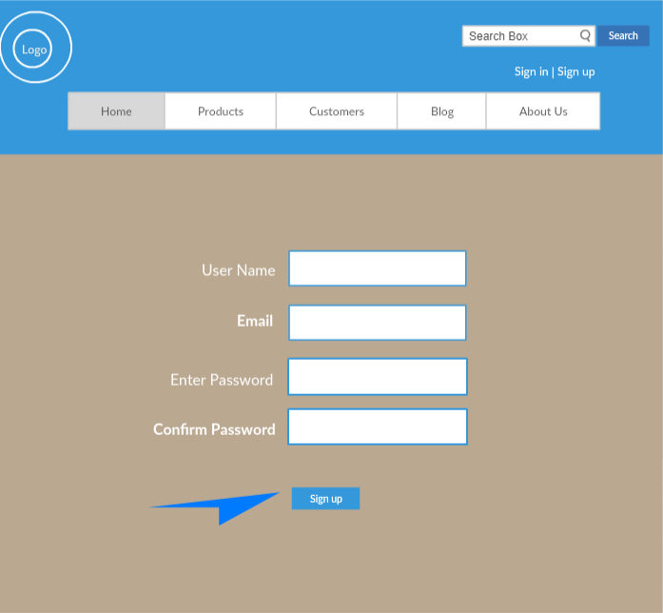

**Architecture Diagrams :**

1. Class Diagram :

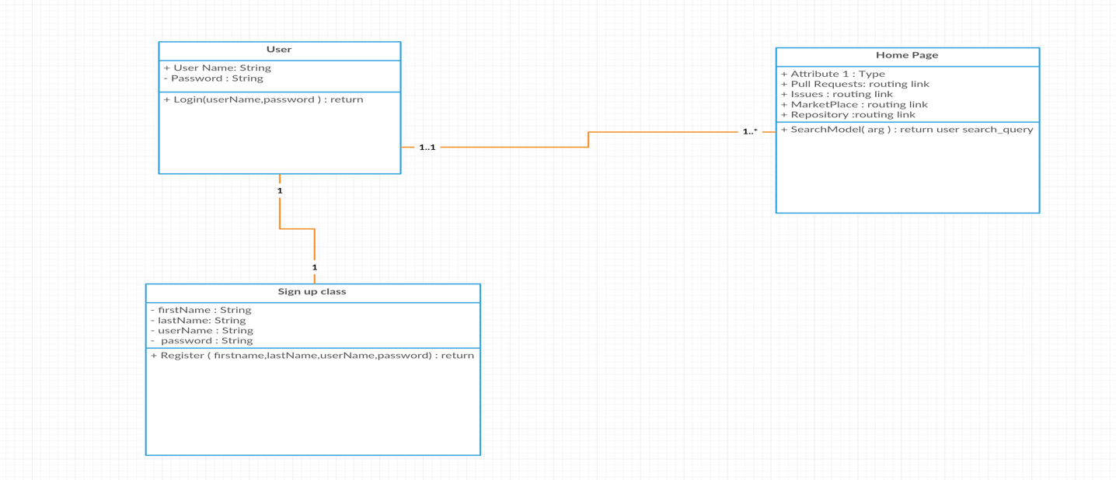

1. **Sequence Diagram:**

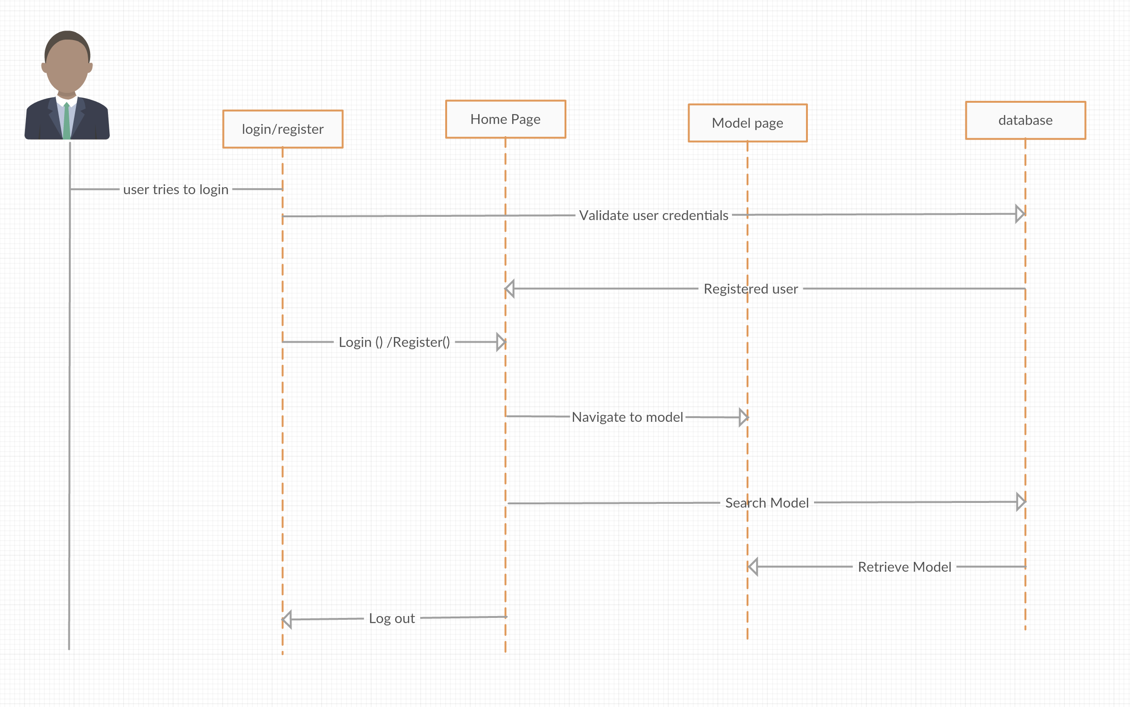

3.Architecture Diagram:

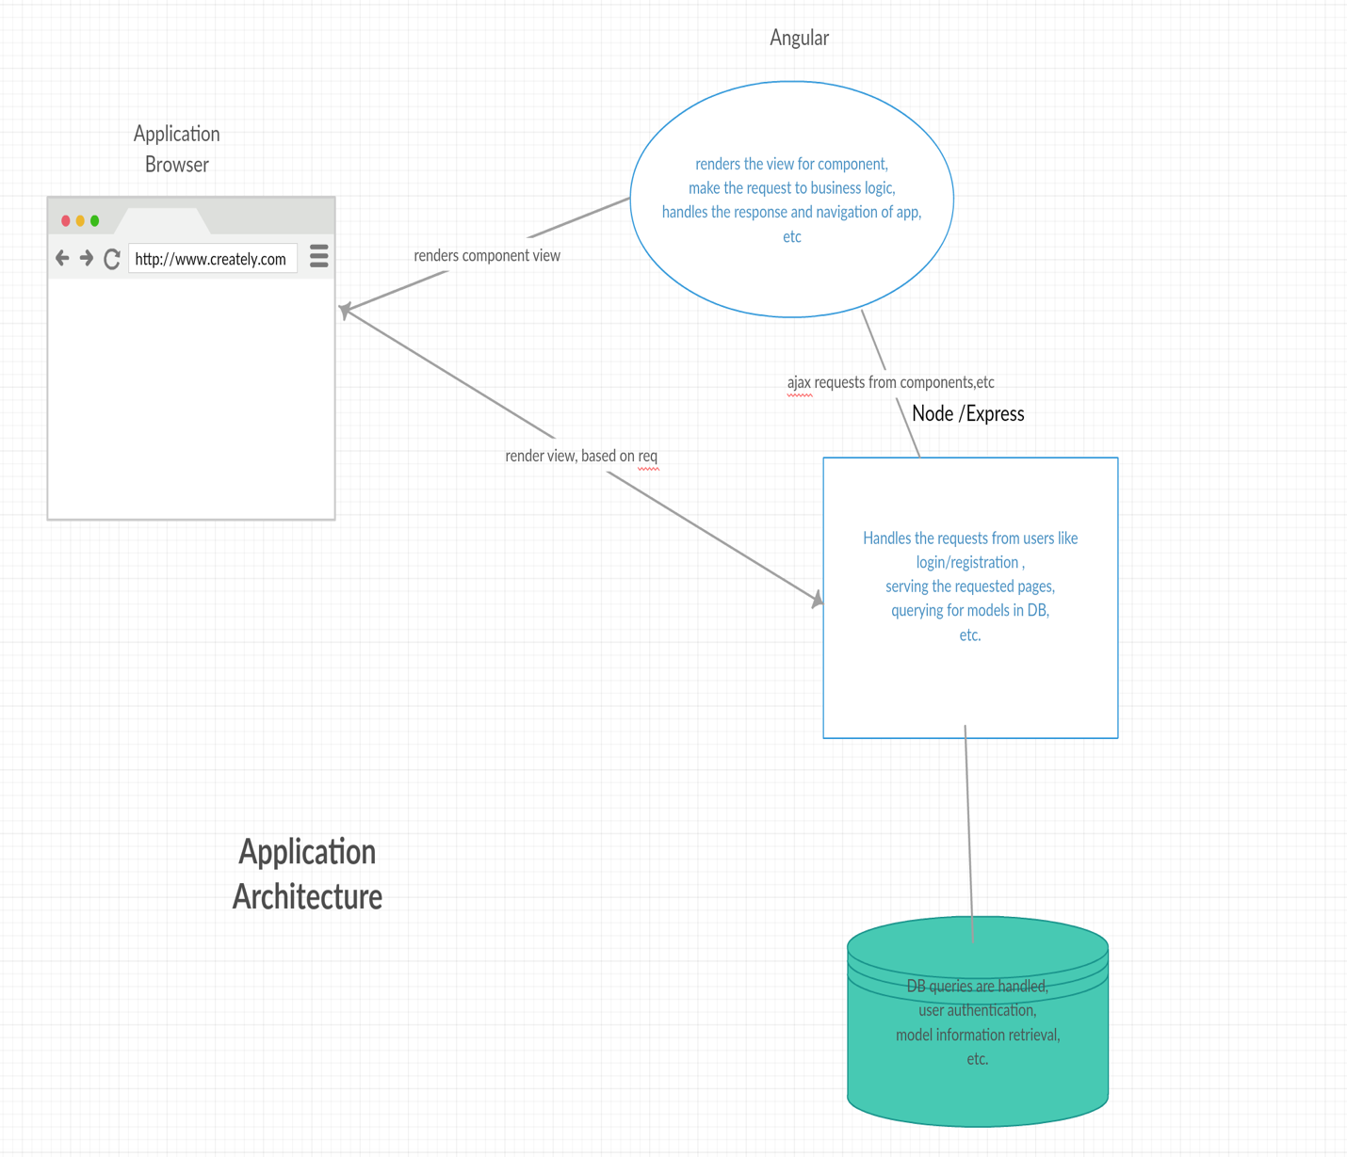

**Implementation:**

Created application in WebStorm which has login page and registration page where user can register to use the services provided in the application and. Below are the steps involved in creating the application.

1. Created a login page for the user to login and use the various services provided in the application.

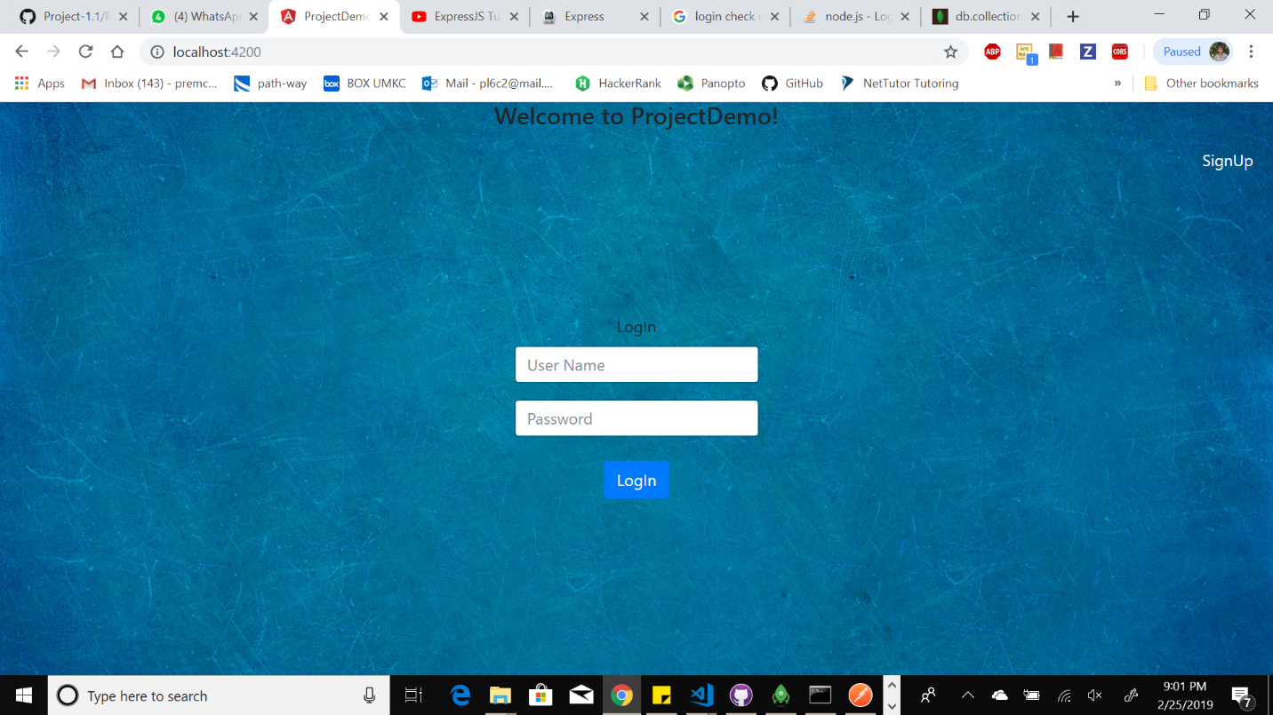

1. If the use is new to the application or never used the application he should register using registration page or user can login using Google account.

Registration Page:

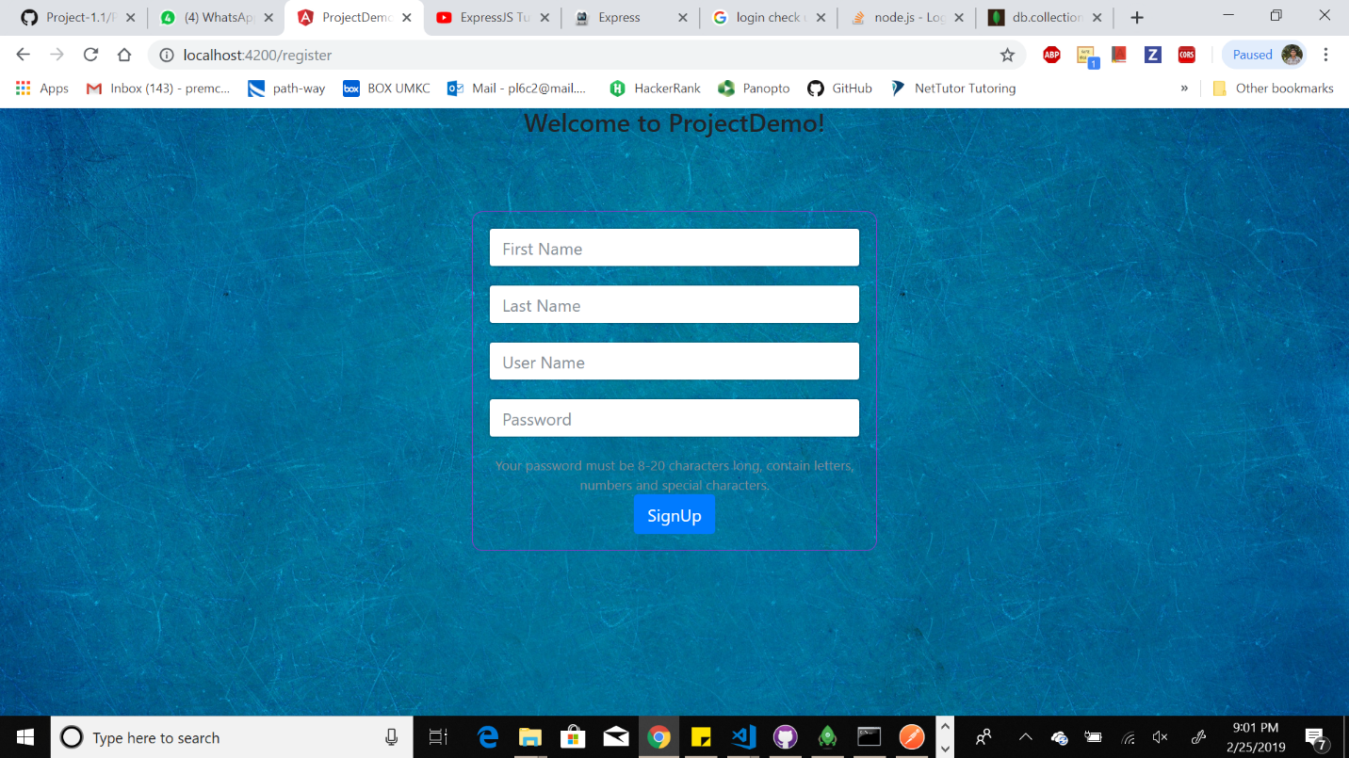

1. After user login into the application he can use all the services that are available in the application. After login the user will redirects to the main page where user can see his repositories , can go to his profile and search for the existing repositories.

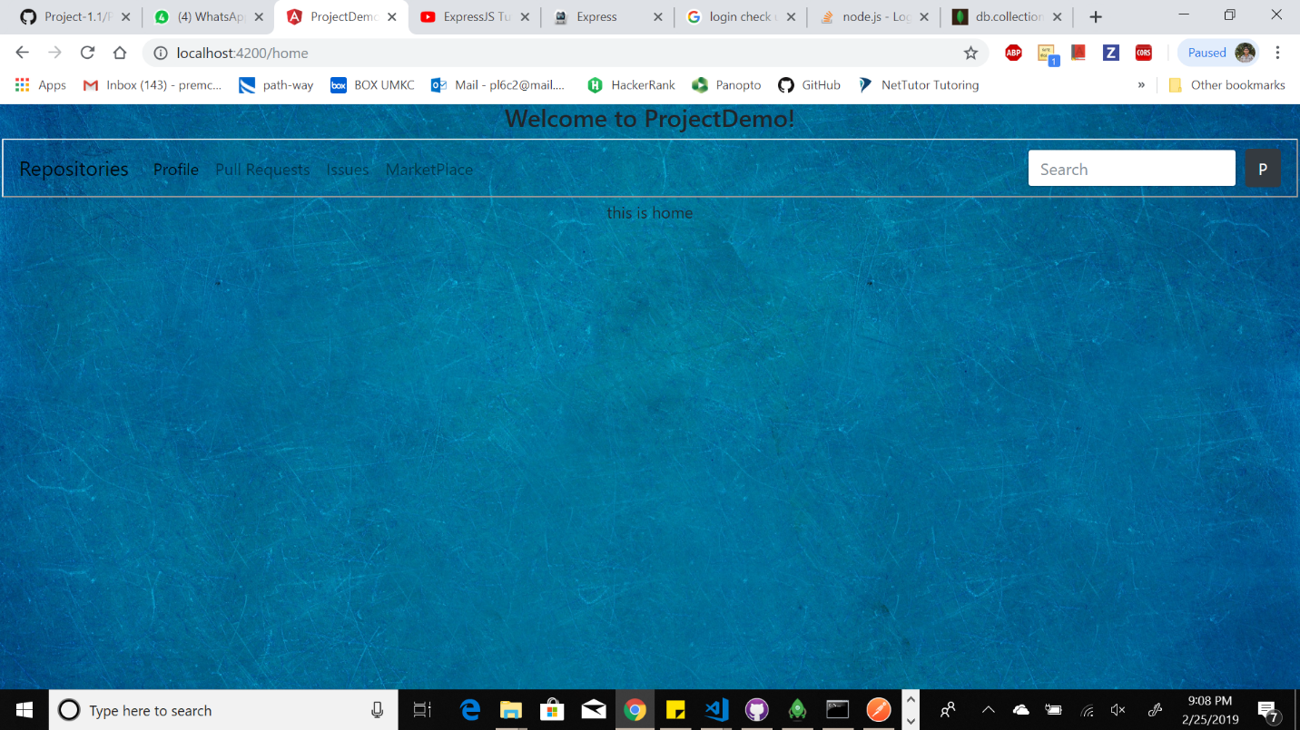

1. When user clicks on signup button the details will be saved in mongodb. Implemented the backend with Express JS. We can see the collections in mongodb using tool called ROBO3T. My collection name is host and I have one sample record.

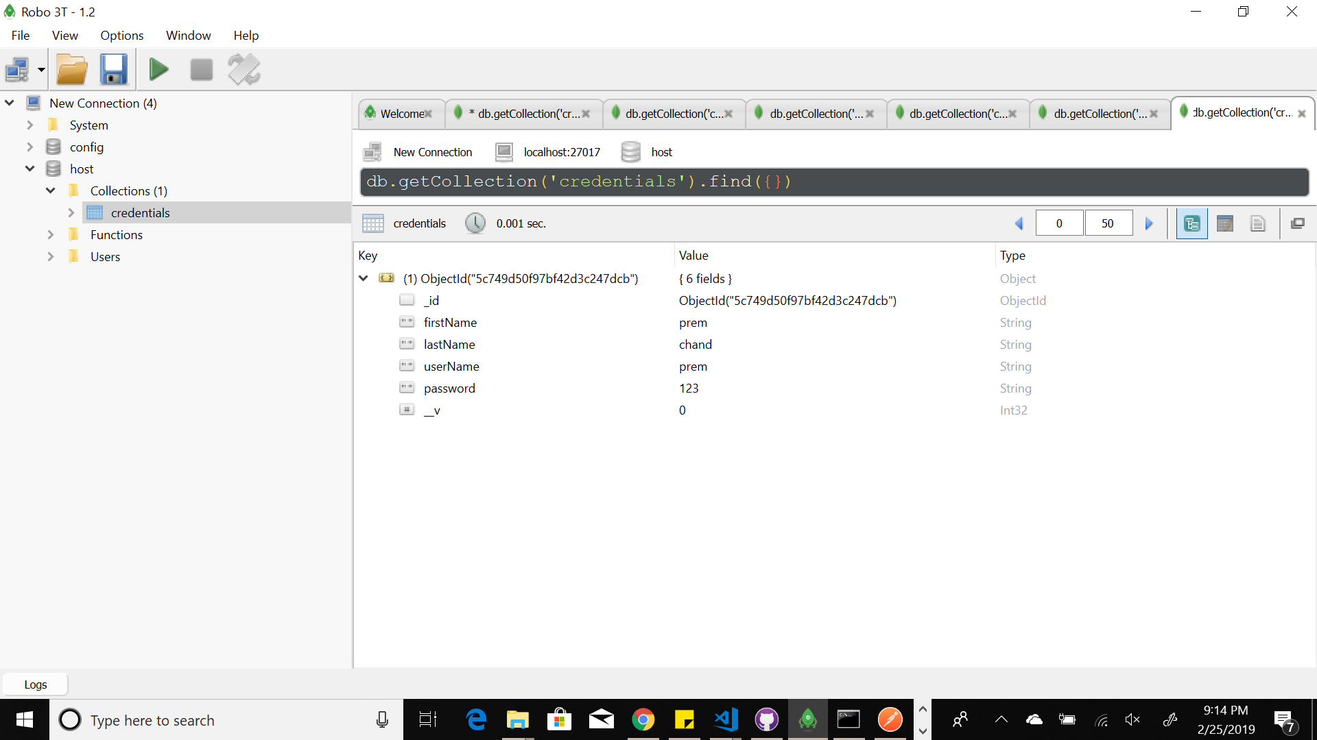

**Project Management:**

**Implementation Status Report:**

**Work Completed:**

1. **Login Page** – Login Page is the first page of the application where user will be able to login with his username and password and if the user is new to the application, he/she can register with register page.

**Responsibility and Time Taken:**

* Vamsi Draksharam – Designed the Login Page (5 days)
* Goutham Gandreddi- Implemented the login page (8 days)
* Premchand Lingamgunta – Tested the login page (5 days)

1. **Registration Page –** new users are provided an option to register using the register button, which will route to register page where he will he/she should enter the various details and the basic validations are performed using JavaScript.

**Responsibility and Time Taken:**

* Premchand Lingamgunta – Design and Implementation of the registration page (5 days)

1. **Home Page** – when the user credentials are validated in the database and if correct credentials are entered, user is routed to application home page.

**Responsibility and Time Taken:**

* Premchand Lingamgunta –Implementation of the home page.
* Goutham Gandreddi - Design the layout for home page.

1. **Architecture and Wireframe Diagrams**: Describes the various functionality of the application.

**Responsibility and Time Taken:**

* Vamsi Draksharam– Designed wireframes, architecture and blueprint of the project (5 days).

1. **Class and Sequence Diagrams: Explains the functionality of the application and documentation.**

* Goutham Gandreddi - Designed the class and sequence diagrams.